INDEX
1. Abstract 2
2. Glossary 2
3. Introduction 3
4. State of the art 3
4.1. Types of humidifiers 3
4.1.1. Evaporative Humidifiers 4
4.1.2. Impeller Humidifiers 4
4.1.3. Ultrasonic Humidifiers 5
4.1.4. Warm Mist Humidifiers 5
4.1.5. Humidifier with an air compressor 5
4.2. Solutions for controlling 5
4.2.1. PLC 6
4.2.2. Microcontrollers 6
4.3. Conclusions 6
5. Project Development 7
5.1. Architecture 7
5.1.1. Fan 8
5.1.2. Water tank 9
5.1.3. Structure 11
5.2. Filter 12
5.3. Controlling system 13
5.3.1. Control system: 13
5.3.2. Program: 14
5.3.3. Main parts of the program: 15
5.4. Electrical and electronic parts 19
5.4.1. Electrical and control sketch : 21
5.4.2. Final model of evaporative humidifier : 24

Abstract

In the text we will show how to make a humidifier with a web interface control. The goal of our project is to keep under full control the humidity level of a 80 m³ server room. We will go through, step by step, from choosing type of humidifier, control, and web interface we are planning to buildup.

Glossary

Arduino UNO -The Arduino Uno is a microcontroller board based on the ATmega328 .
It has 14 digital input/output pins (of which 6 can be used as PWM outputs), 6 analog inputs, a 16 MHz crystal oscillator, a USB connection, a power jack, an ICSP header, and a reset button. [13],[19].

Ethrnet card- a kind of network adapter. It support the Ethernet standard for high-speed network connections via cables. [32]

ICSP - In Circuit Serial Programming, a method of directly programming form microcontrollers.[31]

Java - Is a programming language originally developed by James Gosling at Sun Microsystems (which is now a subsidiary of Oracle Corporation) and released in 1995 as a core component of Sun Microsystems' Java platform.

Marketing plan - Plan sales, marketing or marketing (Marketing Plan) is a written document that details the actions necessary to achieve a specific objective of the market

µC, MCU – microcontroller - is a small and low-cost computer built for the purpose of dealing with specific tasks. [10]

PLC - Programmable Logic Controller – digital device, used to automate electromechanical processes. [9]

PWM outputs - Pulse-width modulation, a commonly used technique for controlling power to inertial electrical devices, made practical by modern electronic power switches. [30]

Relative humidity - The measurement of water vapor in the air and water vapor mixture [33]

Introduction

This report describes how to build and implement a portable humidifier controlled via a web interface. This report also introduces to the reader different types of humidifiers shows which best suits our needs: possess the temperature sensors, water level sensors in the tank, how and which elements will be connected with the web interface.

This report is divided into 4 parts:
- introduction, where we will present the problem, objectives and work plan;
- state of the art, where of humidifiers will be introduced;
- project development, where the process of building the humidifier will be presented;
- conclusions, where problems and achievement will be discussed;

Our main objective is to build a humidifier with a web interface for a data center of 80 m³. The relative humidity which should be maintained -with the use of the humidifier- is between 40 % and 70 % (± 5). It should be autonomous for two days and it should posses water and humidity alarms. Moreover, a good distribution of water vapor is expected. The humidifier should be compliant with the EU Directives 2006/42/CE 2006-05-17 and 2006/95/CE 2006-12-12.

We analyzed data from Data Center – the temperature and humidity - and we found out that the relative humidity drops below 40%, the lowest we observed was 36%. This problem escalates during summer when the temperature outside is very high. That is the reason why we need to install humidifier.

In order to make our work more efficient, we distributed tasks between all members of the team. To be sure that all tasks will be completed on time, a Gantt chart was created. Marta and Ivan were responsible for the humidifier and composite box, while David and Peter were responsible for the controlling system and creating the web interface.

State of the art

Why humidifying a data center is so important? If the relative humidity drops below 40%, the excess of static electricity may cause sparks which can damage servers and IT equipment. A high level of humidity is also inconvenient for electrical machines. Both situations may cause server downtime and may lead to serious equipment damage and, consequently to large cost.

Types of humidifiers

There are few types of humidifiers which we considered during our search for a good solution to our problem. They are presented below.

Evaporative Humidifiers

In evaporative humidifiers mist is produced by blowing water through a wick filter with the use of a fan. Hot air goes through a wet filter causing the increase of humidity and decrease of temperature. The mineral dust and bacteria get trapped on the filter before the water evaporates into the air. The advantage of this kind of humidifier is that the wick filter ensures a pure and clean mineral-free moisture output. Moreover, fans can be powerful enough to cover large areas with a single humidifier. Power consumption is very low. This solution has also some disadvantages: fans make more noise than other types of humidifiers (noise level depends on fan speed), and bacteria and mold can grow on the wick filter very easily. However, the latter problem may be reduced by using a bacteria treatment water additive, but still most wick filters need to be replaced approximately every 2 months. [1], [2], [3]
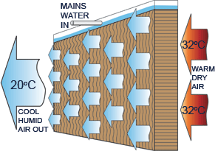
Fig.1. Evaporative humidifier.[5]

Impeller Humidifiers

In impeller humidifiers a fan blows water through a diffuser and, as a result, it produces fine droplets. In contrast to evaporative humidifiers there is no filter, so there is no need to replace, reducing cost of maintenance. Moreover it is very quiet while working. Additionally, these humidifiers have low power consumption and are cheaper than evaporative humidifiers. On the other hand, there is risk that bacteria and minerals can spread in the air along with the mist, what may cause white dust. Its use is limited to small rooms. [1], [2], [3]
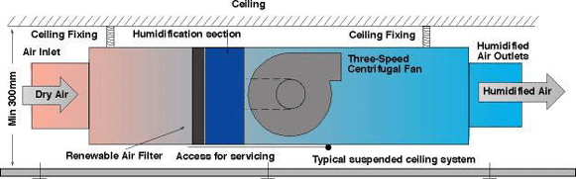
Fig. 2. Impeller humidifier. [4]

Ultrasonic Humidifiers

Ultrasonic humidifiers use high-frequency vibrations to dissipate water into the air. This method is the quietest of all. Additionally, the power consumption is very low (when using cool mist) and there is no need for replacing filters. However, there may occur white dust formation as in the case of impeller type of humidifier. Like the previous methods, the ultrasonic humidifiers are reserved for small rooms only. [1], [2], [3]

Warm Mist Humidifiers

These humidifiers heat the water and expel steam into the room. Water is heated and mixed with the air as a vapor. This method is very quiet and produces pure and clean mineral-free moisture output. Furthermore, there are no filters to replace. On the other hand, there is a higher power consumption (heating element uses more electricity than other types of humidifiers) and it is limited to small rooms only. [1], [2], [3]
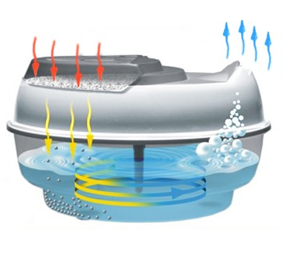
Fig. 3. Warm mist humidifier.[8]

Humidifier with an air compressor
The water is blown into the air through nozzles that mix high-pressure air with water. Due to the high-pressure air, the water is dispersed of the water vapor trough the nozzle. This method is very effective and provides a good distribution. However, it is high energy consuming. Additionally, it is very expensive to build this type of humidifier.

Solutions for controlling

There are two basic way to solve the controlling. Our objective to choose one from these tools what is the best to realize the controlled humidity-level in a server room. The options are the following:

PLC
PLC is a digital computer used for automation of electromechanical processes. [9] PLCs are used in many industries and machines. PLCs have standard inputs/outputs, and may include Ethernet connection. The most important feature of the PLC is their universal usability, but usually PLCs are used in industry. The main difference from other controllers is that PLCs are armored for severe conditions (such as dust, moisture, heat, cold) and have the facility for extensive input/output (I/O) arrangement sallow the PLC to connect with sensors and actuators. PLCs read limit switches, analog process variables (such as temperature and pressure), and the positions of complex positioning systems. On the actuator side, PLCs operate electric motors, pneumatic or hydraulic cylinders, magnetic relays, solenoids or analog outputs. The input/output arrangements may be built into a simple PLC, or the PLC may have external I/O modules attached to a computer network that plugs into the PLC.

Microcontrollers

A microcontroller is a device that can be used to control some process. It includes a processor core, memory, and programmable inputs/outputs integrated in a small card. [11] Microcontrollers are used to automatically control processes and devices. By reducing the size and cost compared to a dedicated design that uses a separate microprocessor, memory, and input/output devices, microcontrollers make it economical to digitally control devices and processes. The microcontroller can be programmed to perform several functions and when equipped with an Ethernet card provides standard web interface. These devices µC-s have low energy consumption (mW or μW). Microcontrollers are more sensitive to the environment (chemical material, temperature, etc.) than PLCs.

Conclusions

In our project we made unformed choices based on the competitive analysis of the different possibilities. Finally, we decided in favor of an evaporative humidifier because it is very cheap to build as well as to maintain. Moreover, this method provides easy control and distribution of water vapor.
Due to the price, size and low energy consumption we selected a microcontroller for controlling. To make these decisions we used comparison tables with points, where 5 was considered as the best, while 1 was the worst mark.

Tab. 1. Table with points for each humidifier.
 | Ultrasonic humidifier | Evaporative humidifier | Humidifier with the air compressor | Impeller humidifier
Cost | 3 | 5 | 1 | 3
Maintenance cost | 3 | 3 | 4 | 4
Consumption of energy | 4 | 4 | 1 | 3
Complexity | 3 | 5 | 1 | 3
Size | 2 | 1 | 4 | 4
Efficiency | 3 | 1 | 5 | 3
Control | 4 | 4 | 5 | 2
Total | 22 | 23 | 21 | 22

Tab. 2. Comparison between PLC and microcontrollers
 | Microcontroller |  | PLC
Cost | 4 |  | 2
Power Supply | 12 V | 3 | 230 V | 3
Programming | 3 |  | 4
Inputs/outputs | 5 |  | 5
Ethernet | 5 |  | 5
Total | 20 |  | 19

Project Development

The project started with a visit to the server room for which the humidifier was designed. We could see how much space there is and where it is possible to place the new equipment. Next step was to choose the type of humidifier – as it was said we decided for evaporative one. We were also considering ultrasonic or the one with air compressor, but this solution is the smaller and very economic.

Architecture

We had to design our own project, which would fit perfectly to the data center.

This evaporative humidifier consists of fan, pump, water tank, and cloth which are used as filter. Cloth should be wet all the time, so an aquarium pump sprays it with the water from tank. The fan sucks water from cloth and then it blows as small particles of water. It is controlled by Arduino with Ethernet card and it communicates with humidity sensors, water level sensors in tank and switches off on a pump and a fan.

Fan

First, we thought about a typical domestic fan, but we did not know how to fix the filter. After that, we thought about a kitchen extractor because it has a metal filter and we could change it for cloth. Moreover, it is possible use a tray, which is under the kitchen extractor to flow the excess water to the tank.

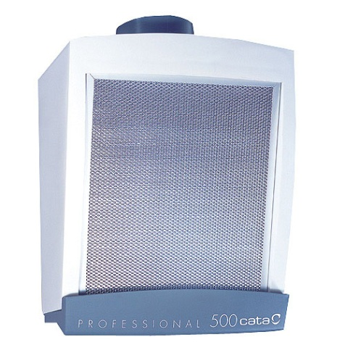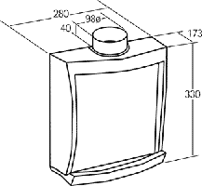
Fig. 4. Kitchen extractor
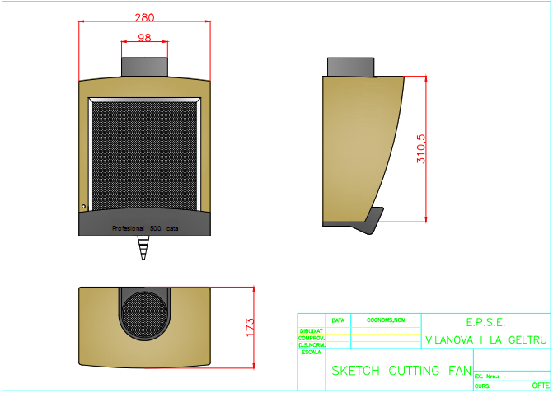
Fig. 5. Sketch of a fan

Although, an idea was good, it still needed some changes. We wanted water to flow on the filter, so we made a hole in left down side to put inside the extractor a pipe with diameter of 8 mm. This pipe is fixed in a top of the filter. Then we made 8 holes in the pipe to flow the water. Finally, we made another hole in the middle and in front of the tray to flow an excess of water to the tank.
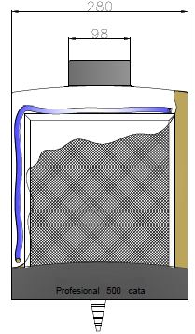
Fig. 6. Extractor modifications

Water tank

In order to find a proper size of water tank, first we made a table with data about humidity and temperature in the data center. After that, we tried to calculate how many liters of water will be needed for the humidifier to work two days without refill. We used this website to help us: http://www.lenntech.com/calculators/humidity/relative-humidity.htm
It was difficult to calculate exactly how much water we need because the temperature is not constant. However, we estimated that ten liters will be enough, even for the worst case, when the humidity is very low. Moreover, we were looking for tank with cover, which fits perfectly in order to prevent vaporization of water.

Tab. 3. Humidity and temperature
Relativehumidity 1m³(g)
 | 15°C | 20°C | 21°C | 22°C | 23°C | 24°C | 25°C | 30°C
10% | 1,28 | 1,7 | 1,82 | 1,94 | 2,06 | 2,18 | 2,3 | 3
20% | 2,56 | 3,4 | 3,64 | 3,88 | 4,12 | 4,36 | 4,6 | 6,1
30% | 3,84 | 5,1 | 5,46 | 5,82 | 6,18 | 6,54 | 6,9 | 9,1
40% | 5,12 | 6,8 | 7,28 | 7,76 | 8,24 | 8,72 | 9,2 | 12,2
50% | 6,4 | 8,5 | 9,1 | 9,7 | 10,3 | 10,9 | 11,5 | 15,2
60% | 7,68 | 10,2 | 10,92 | 11,64 | 12,36 | 13,08 | 13,8 | 18,3
70% | 8,96 | 11,9 | 12,74 | 13,58 | 14,42 | 15,26 | 16,1 | 21,3
80% | 10,24 | 13,6 | 14,56 | 15,52 | 16,48 | 17,44 | 18,4 | 24,4
90% | 11,52 | 15,3 | 16,38 | 17,46 | 18,54 | 19,62 | 20,7 | 27,4
100% | 12,8 | 17 | 18,2 | 19,4 | 20,6 | 21,8 | 23,1 | 30,4

Tab. 4. Humidity and temperature for 80 m³
Relative humidity/ 80m³ (g)
 | 15°C | 20°C | 21°C | 22°C | 23°C | 24°C | 25°C | 30°C
10% | 102,4 | 136 | 145,6 | 155,2 | 164,8 | 174,4 | 184 | 240
20% | 204,8 | 272 | 291,2 | 310,4 | 329,6 | 348,8 | 368 | 488
30% | 307,2 | 408 | 436,8 | 465,6 | 494,4 | 523,2 | 552 | 728
40% | 409,6 | 544 | 582,4 | 620,8 | 659,2 | 697,6 | 736 | 976
50% | 512 | 680 | 728 | 776 | 824 | 872 | 920 | 1216
60% | 614,4 | 816 | 873,6 | 931,2 | 988,8 | 1046,4 | 1104 | 1464
70% | 716,8 | 952 | 1019,2 | 1086,4 | 1153,6 | 1220,8 | 1288 | 1704
80% | 819,2 | 1088 | 1164,8 | 1241,6 | 1318,4 | 1395,2 | 1472 | 1952
90% | 921,6 | 1224 | 1310,4 | 1396,8 | 1483,2 | 1569,6 | 1656 | 2192
100% | 1024 | 1360 | 1456 | 1552 | 1648 | 1744 | 1848 | 2432

Tab. 5. Humidity and temperature chart
 | Totalize Min. Humidity (%) | Totalize Max. Humidity (%)
MeasuredValues | 33 | 67
UsedValues | 30 | 70
 | Min. Temperature (°C) | Max. Temperature (°C)
MeasuredValues | 18,8 | 25,4
UsedValues | 15 | 30

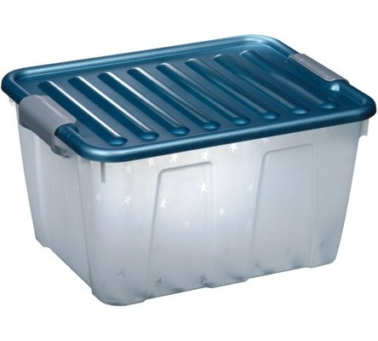
Fig. 7. Water Tank
When we finally found the proper tank, we still had to make some changes. We made two holes for the water sensors level. Before that, we calculated the volume and we decided to make the first hole when in the tank there are 6 liters of water - when water level is below the first water sensor alarm is send. We made second hole, when in the tank there are 3 liters – this is minimal amount of water needed for pump to work properly.

We made three holes in the lid of water tank - one for the water pipe from pump to the extractor (Ø 8mm), second for pump's electrical cable, and the last one, the biggest, to flow the water excess to the tank - this hole is protected with a rubber gasket.

To make refilling the tank easier, we cut the lid in two parts and joined them with a hinge and then we taped up to make it more hermetic.

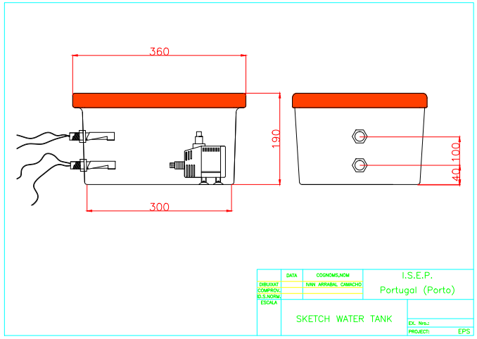
Fig . 8. Water Tank modifications

Structure

We thought about a structure to organize all equipment. At the beginning we wanted to build it our own using aluminum, but then we found furniture for bathrooms, made of aluminum and that seemed to be perfect solution of this problem.

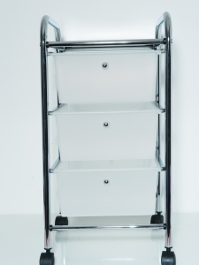
Fig. 9. Structure

This structure is very good for our needs. However, we had to modify it a little. We changed the metal platform in the lowest level and fixed another metal bar in the middle in order to fix the extractor. Finally, we fixed two 90º aluminum angles to fix the electrical box.

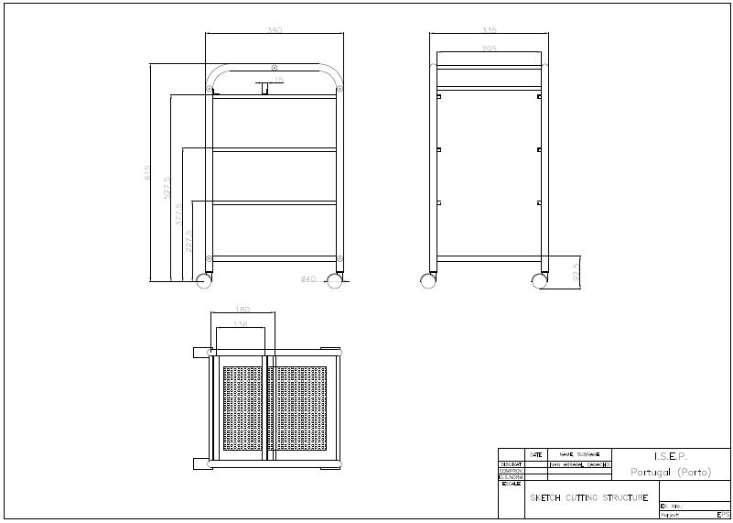
Fig. 10. Structure modification

Filter

We were looking for materials which could be used as filters. We made test for all of them. For this purpose we used a hairdryer, pc fans and different materials and we measured the humidity. By this test we also proved that our humidifiers will work. We did two tests, because during first one the measurements were incorrect, but we picked up three that seemed to be the best. During tests we considered hygroscope, how fast it dries and the differences in the humidity. Finally, we decided for professional filter for humidifiers – although it is a bit more expensive, it is much more efficient and durable, so there will be no need to change it so often.
And to improve the efficiency of our humidifier we decided to mix the professional filter and another filter from the kitchen "Vileda" (viscous fiber, polypropylene and cotton).

(a) (b)
Fig. 11. (a) Polypropylene and cotton filter; (b) Professional filter

Controlling system

Control system:

This humidifier controlled by Arduino Uno. The Arduino Uno is a microcontroller board based on the ATmega328 (datasheet). It has 14 digital input/output pins (of which 6 can be used as PWM outputs), 6 analog inputs, a 16 MHz crystal oscillator, a USB connection, a power jack, an ICSP header, and a reset button. It contains everything needed to support the microcontroller; simply connect it to a computer with a USB cable or power it with an AC-to-DC adapter or battery to get started.
The Uno differs from all preceding boards in that it does not use the FTDI USB-to-serial driver chip. Instead, it features the Atmega8U2 programmed as a USB-to-serial converter.

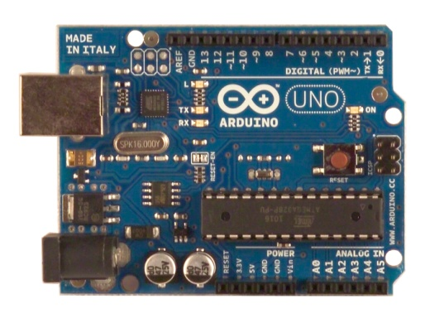
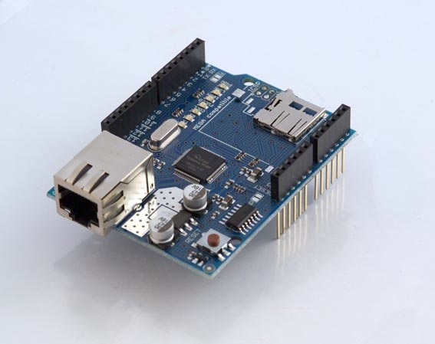
(a) (b)

Ethernet card is able to communicate with the Server computer and then retrieve the values ​​of sensors and it has the ability to send data.
Fig. 12. (a) Arduino Uno; (b) Arduino Ethernet card
In accordance with customer expectations the humidifier will use the 3 currently installed humidity sensors values and values of 5 more humidity sensors which will be installed in the future and it will use one built-in sensor for that case when no connection.
Ethernet connection will be also used for sending warning emails when the water level is under the second safety level.
On the inputs there are two water level sensors, and a built-in humidity sensor. A fan and a pump are connected to Arduino outputs trough relays. The warning LEDs are on a outputs too or on a parallel way of the controlled part.
When Arduino gets the data from the server, it checks the date. If a data is not available or a date is not correct, we do not use those values, we will use the lowest value of the correct values. Based on the lowest value Arduino switch on the pump for 6 seconds, then turn on the fan for 3 minutes if the humidity level is under 55%. If the humidity level is under 45% the working times change to longer. Above 55% it does not switch on again the pump and the fan, and in all cycle send a signal to relays to switch off a pump and a fan.
The water level is monitored too, by two switches. When the lowest water level sensor is closed, it means that there is not enough water in a water tank. Running without water is harmful to for a pump, therefore if there is not enough water, switches of pump and fan are blocked, and a signal is send to relays to turn off. Furthermore Arduino send an email to the chief of the data center about the water level when the level is under the second safety level.

Program:

Variables:

Global variables:
- const String s1 and const String s2: HTTP codes, between this two string changes the number of the humidity sensor to get humidity values from data server.
- const String s3: HTTP code to get date from the TomCat server.
- const int SENSOR_NUMBER: constant number of the humidity sensors in the data server.
- const int NOT_FOUND: constant variable t compare the reply if no data available.. Five sensors from the eight are not installed yet.
- byte mac[] : MAC address of Arduino.
- byte ip[] : IP address of arduino.
- byte server[] : IP address of the Data server
- int min_value: The minimum humidity value of the eight sensor of the data centre and the one built-in sensor.
- int water: is a flag for water level. If it’s “1” the humidifier runs are allowed, if it’s “0” it means not enough water for the pump and the run is banned.
- int server_minutes:
- int sensor minutes:
- boolean email: is another flag for email sending. “0”: email sending is allowed. “1”: email send was successful and it blocking the email sending while the water has filled up.
- String server_date: the answer when the program calls the date from the server.
- String sensor_date: part of the reply what included just the date of the sensor.
Local variable:
- Local_Humidity():
- int LHS: current humidity level from the built-in sensor(read from analog pin 0).
- Water_Control():
- int WLS1: the firs water level switcher state(read from digital pin 7).
- int WLS2: state of the second water level switcher(read from digital pin 8).
- String alarm: It’s a message to the serial monitor about the water level.
- SendMail():
- Client Emailclient: availability of the email server.
- getDataFromServer():
- Client client: availability of the data server.
- String extract_server_date: current date of the data server.
- String extract_sensor: current date of eight humidity sensor.
- float getValue: humidity level from the eight sensor.
- int finish: end of the humidity value in the reply.
- float res: value of the humidity (8 sensors) from the reply in float format.
- String roi: value of the humidity (8 sensors) from the reply in string.
- String reply: the answer of the data server that include sensor Id-s, dates, and the humidity values. From this reply we have to take out the important data.
- int getHours: this string get the hours from the time .
- int h: number of hours.
- int getMinutes: this string get minutes from the time.
- int m: in the current time the number of the minutes.
- String getTimeInMinutes: thin string convert hours and minutes from the current time to minutes.
- (1 )int counter: counter 1-8.
- (1) int nchars: number of the characters.
- getDate():
- (1)char c: one character from the date reply, changes letter by letter.
- (2)int nchars: number of the characters.
- getHumidity():
- (2) int counter: counter 1-8.
- (2) char c: character from the reply, changes letter by letter.
- int value: eight humidity values.

Main parts of theprogram:

Void setup:

In this part, the program set the pins to outputs or inputs. Furthermore initialize the connection to data server.
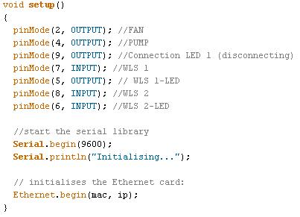

Humidity control based on local humidity sensor:

Those seven lines read value from the local humidity sensor and put into the “min_value” if it is lower than the “min_value”. The “min_value” variable is that variable which the program use as current humidity value.
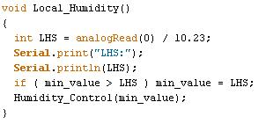

Fan and pump control:

This is a real part of humidity control, in this part we control when time turn on and off, and how long time will run the pump and the fan if the humidity level is under 55%.
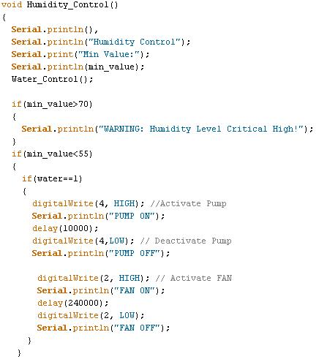

Connectionto Data server:

“void Connection () “ makes connection between the TomCat server and Arduino. If the connection was not successful, and it repeat the process again and again while not connect. For the period, while the connection is not prosperous the program will use just the local humidity sensor values.
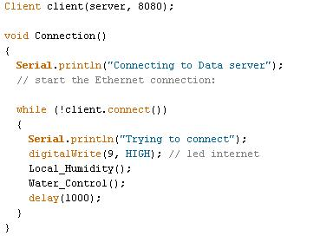

Connectionto email server:

It is the same process like “void Connection()”, but here Arduino connecting to the email server.
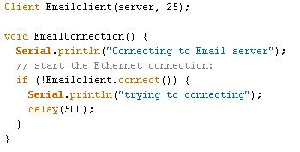

Sending email:

This module is sending a water level warning email.
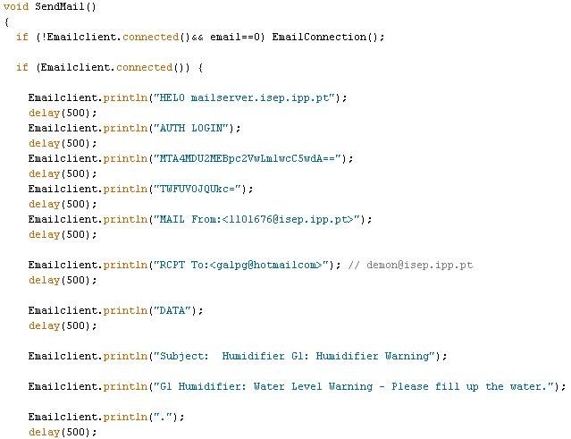

Operation cycle:
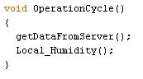
There are three more functions in the program. One is call the current date from the data server, than call the date of values and compare it. The program will ignore values with incorrect date. And in another function the program get the humidity data from the server. In the case when “no data available” or the value is 0 will ignore too.

Electrical and electronic parts

In the Arduino card there are two inputs and two outputs. We have to control the extractor and the water pump. To control it, we chose two relays (FINDER 40.31 6V DC). More details can be found in datasheet (http://uk.farnell.com/finder/40-31-9-006-0000/relay-pcb-spco-6vdc/dp/1169157). Due to the fact, that Adriano’s outputs works with 5V, the coil needs to work also at such voltage.

Because we work with maximum current that Adriano can hold, we decided to make additional electronic circuit.

To activate the relay coil we used a transistor (BD137) in case, when the Arduino does not give enough power. We also used a protection diode (1N4001) to remove the current induced by turning off the coil.

We needed to calculate the resistance of the circuit

Using the transistor BD137 with hfe = 170

$$Rcoil=55Ω$$

$$V=5V$$

$$I=\frac{5V}{55Ω}=0,09 A$$

$$hfe=\frac{Ic}{Ib}=>Ib=\frac{Ic}{hfe}=\frac{0,09A}{170}=5,29·{10}^{-4}A$$

$$R= \frac{Varduino}{Ib}=\frac{5V}{5,29·{10}^{-4}A}=9481,80Ω$$

We choose one of 10K$Ω$

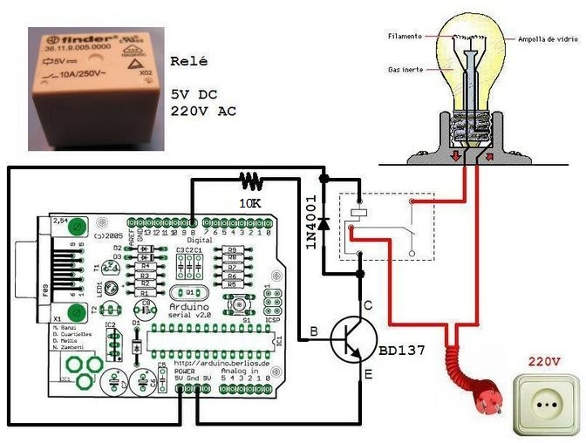
Fig. 13.Relay additional electronic circuit
We have another problem because the switch it's not a commutator and the input of Arduino needs a real 0 to understand the 5V from sensor level.
We put a resistance from 10KΩ to do the commutation.
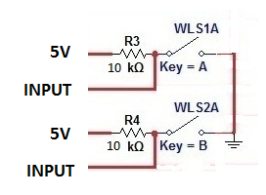
Fig. 14. Sensors additional electronic circuit
We need a power supply to convert 230V AC to 12V DC because Arduino works with lower

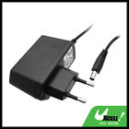
Fig. 15.Power supply

Electrical and control sketch :
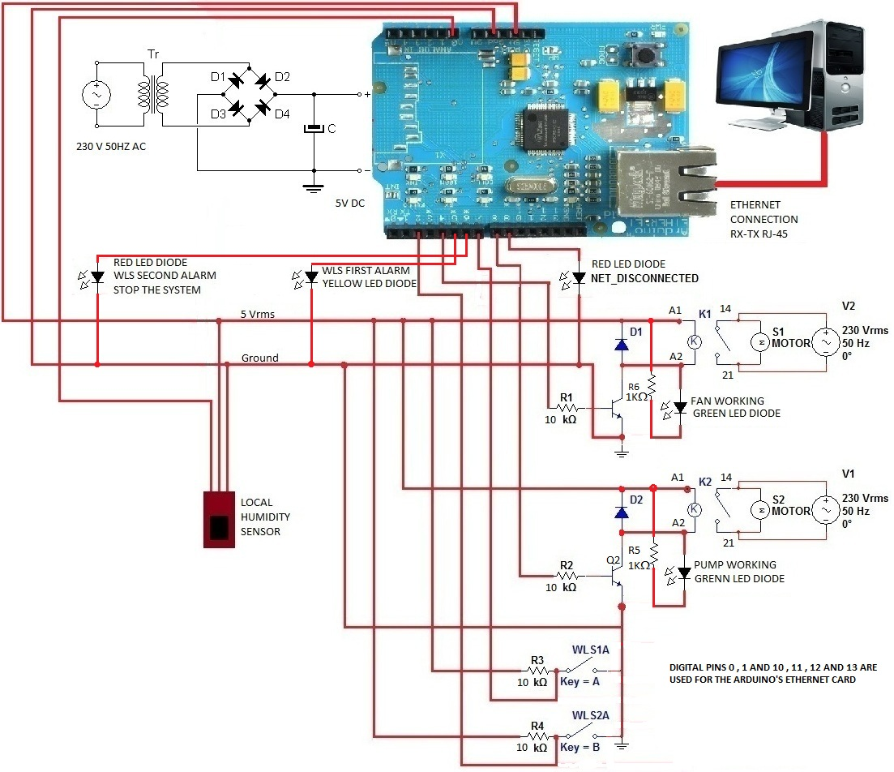
Fig. 16. Electrical and controlling sketch

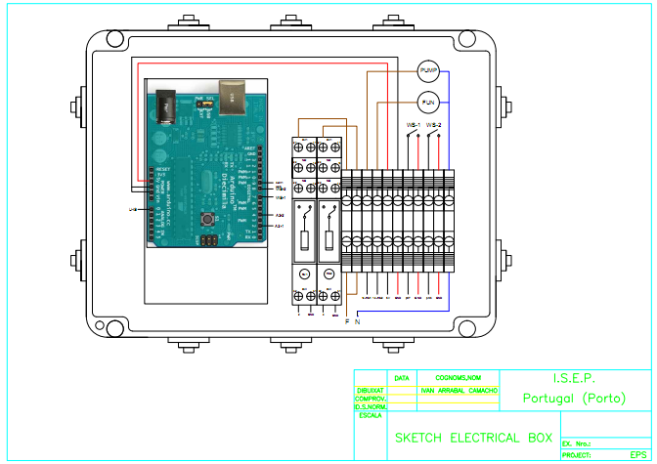Fig. 17. Electrical box

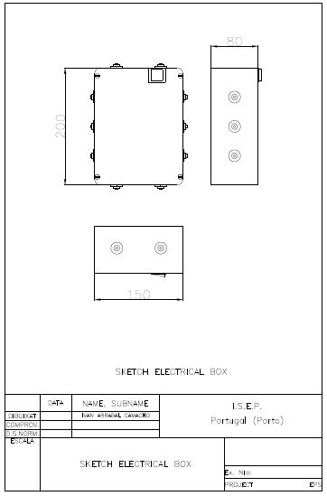
Fig. 18. Electrical box

Final model of evaporative humidifier:

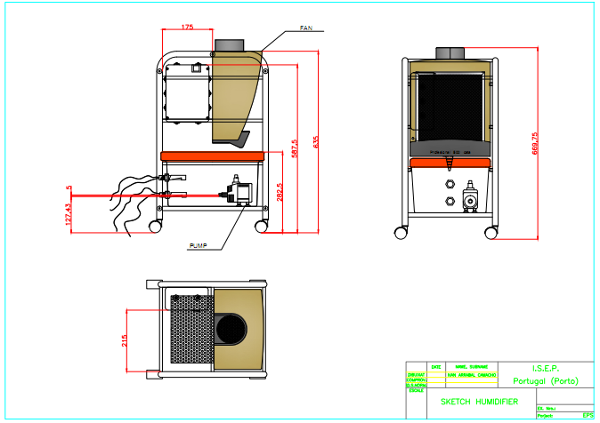
Fig. 19.Final model of humidifier

Functionalities

Beyond the humidifying, this humidifier has some additional functions too. It sends data to the TomCat server about the two water level switch state and also sends an e-mail when the water level falls below the allowable.

Conclusions

Discussion
We had few problems during performing our project. Our greatest problem was fact that none of us had an experience in this type of work. We had problems with team work, but finally we manage to find a solution. Moreover, no one of use had an idea about humidifiers or web interface. We also had a great problem with lack of motivation, but fortunately we mobilize ourselves.
When we were looking for good solution, we could not decide which type of humidifiers will best suit all needs. We were considering ultrasonic humidifier, but we realized it is very complicated and creates additional problems. So finally we decided for evaporative humidifier as it combines good humidifying without a risk of too much humidity in air and simplicity during building.
As it was mentioned we had to repeat testing filters, as the measurements were incorrect.
We had also some problems how to connect the electrical switchers to Arduino and we needed to create a circuit from a transistor, a 10K$Ω$ resistor and a protection diode, because we could not connect Arduino directly to the coil.
The greatest problem was program writing, because none of us has got skills or experience with Arduino’s program language, or with another program language. We had to study about C and C++ language but just on very basic level. The most complicated part for us was to get and check the data and the date from the TomCat server, for this part we needed some help.

Further Developments

- Make coverage around the structure;
- Additional functions based on individual needs (in program or in architecture);

Bibliography

- Iallergy. Humidifier Buying Guide. Available at: http://www.iallergy.com/category11_86/default.html Accessed in March 2011.
- okazje.info. Kupujemy nawilżacze powietrza. Available at: http://www.okazje.info.pl/porada/dom-i-ogrod/kupujemy-nawilzacze-powietrza.html Accessed in March 2011.
- Buzzle.com. Types of humidifiers. Available at: http://www.buzzle.com/articles/types-of-humidifiers.html Accessed in March 2011.
- JS Nawilzacze. HumiPac - ceiling mounted humidifier. Available at: http://www.jsnawilzacze.pl/humipac-ceiling-mounted-humidifier-510-details/ Accessed in March 2011.
- JS Nawilzacze. HumEvap MC3 - nawilżacz wyparny /chłodnica. Available at: http://www.jsnawilzacze.pl/humevap-mc3-nawilacz-wyparny-chodnica-486-details/ Accessed in March 2011.
- Nuclearts.pl Nawilżacze powietrza. Jaki wybrać? Available at: http://nuclearts.pl/dom/nawilzacz-powietrza-jaki-wybrac-czym-sie-kierowac-przy-zakupie/ Accessed in March 2011.
- Projektoskop. Nawilżacze powietrza. Available at: http://www.projektoskop.pl/a-6936-nawilzacz-powietrza.html Accessed in March 2011.
- Media sklep. Available at: http://mediasklep.ogicom.pl/nawilzacz-powietrza-triada.htmlAccessed in March 2011.
- Wikipedia The free encyclopedia - Programmable logic controller. Available at: http://en.wikipedia.org/wiki/Programmable_logic_controller Accessed in March 2011.
- EngineersGarage. Available at: http://www.engineersgarage.com/microcontroller Accessed in March 2011
- Wikipedia. The free encyclopedia – Microcontroller. Available at: http://en.wikipedia.org/wiki/Microcontroller Accessed in March 2011.
- Wikipedia. The free encyclopedia – Humidifier. Available at: http://en.wikipedia.org/wiki/Humidifier Accessed in March 2011.
- Wikipedia. The free encyclopedia – Arduino. Available at: http://en.wikipedia.org/wiki/Arduino Accessed in March 2011.
- EngineeringtoolboxAvailable at: http://www.engineeringtoolbox.com/ Accessed in March 2011.
- AMCO Available at: www.amco.comAccessed in March 2011.
- John Gibson Displays Available at: www.ferret.com.au Accessed in March 2011.
- BryantAvailable at: www.bryant.com Accessed in March 2011.
- Siemens Available at: www.automation.siemens.com Accessed in March 2011.
- Schneider Available at: www.schneider-electric.com Accessed in March 2011.
- ArduinoAvailable at: www.arduino.cc Accessed in March 2011.
- Beyond Logic Available at: www.beyondlogic.org Accessed in March 2011.
- Maxim Available at: www.maxim-ic.com Accessed in April 2011.
- SparkfunAvailable at: www.sparkfun.com Accessed in April 2011.
- PTroboticsAvailable at: www.ptrobotics.com Accessed in April 2011.
- MANN-FILTER Available at: www.mann-hummel.com Accessed in April 2011.
- Beach filters Available at: http://www.beachfilters.com/ Accessed in April 2011.
- Humidifier Filters Available at: http://www.humidifierfilters.com/ Accessed in April2011.
- KAZ Available at: www.kaz.com Accessed in April 2011.
- Filters for home Available at: http://www.filters-for-home.com/Humidifier_Filters.html Accessed in April 2011.
- Wikipedia. The free encyclopedia – Pulse-width modulation. Available at: http://en.wikipedia.org/wiki/Pulse-width_modulation Accessed in June 2011.
- Wikipedia. The free encyclopedia – InCircuit Serial Programming. Available at: http://en.wikipedia.org/wiki/In_Circuit_Serial_Programming_(ICSP)Accessed in June 2011.
- About.com Available at: http://compnetworking.about.com/od/ethernet/f/ethernet_cards.htm Accessed in June 2011.
- Wikipedia. The free encyclopedia – Relative Humidity. Available at: http://en.wikipedia.org/wiki/Relative_humidityAccessed in June 2011.

